PIZZA SALES SQL QUERIES

- Total Revenue
select SUM(total_price) as Total_Revenue from [pizza_sales (3)]

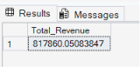

- Average order value
select * from [pizza_sales (3)]

select SUM(total_price) / COUNT(DISTINCT order_id) AS Average_order_value from [pizza_sales (3)]

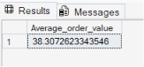

- Total pizza sold

select SUM(quantity) AS total_pizza_sold from [pizza_sales (3)]

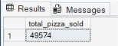

- Total Order
select COUNT(DISTINCT order_id) AS total_order from [pizza_sales (3)]

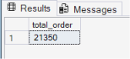

- Average pizza per order
select CAST(CAST(SUM(quantity) AS DECIMAL (10,2)) /
CAST(COUNT(DISTINCT order_id) AS DECIMAL (10,2)) AS DECIMAL (10,2))
AS avg_pizza_per_order from [pizza_sales (3)]
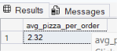

- Daily trend for total orders
select DATENAME(DW,order_date) AS order_day ,
COUNT(DISTINCT order_id) AS total_orders from [pizza_sales (3)]
GROUP BY DATENAME(DW,order_date)

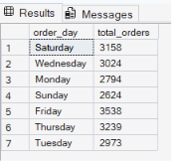

- Monthly trend for total orders
select DATENAME(MONTH,order_date) AS month_name ,
COUNT(DISTINCT order_id) AS total_orders from [pizza_sales (3)]
GROUP BY DATENAME(MONTH,order_date)

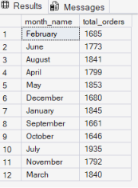

select DATENAME(MONTH,order_date) AS month_name ,
COUNT(DISTINCT order_id) AS total_orders from [pizza_sales (3)]
GROUP BY DATENAME(MONTH,order_date)
ORDER BY total_orders DESC

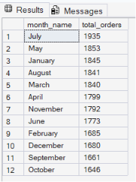
- Percentage of sales by pizza Category
select pizza_category , SUM(total_price) * 100 / (select SUM(Total_price)
from [pizza_sales (3)]) AS PCT
from [pizza_sales (3)]
GROUP BY pizza_category

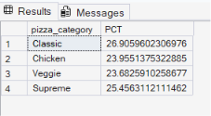

select pizza_category ,SUM(Total_price) AS total_sales, SUM(total_price) * 100 / (select SUM(Total_price)
from [pizza_sales (3)]) AS PCT
from [pizza_sales (3)]
GROUP BY pizza_category
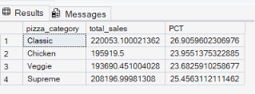

select pizza_category ,SUM(Total_price) AS total_sales, SUM(total_price) * 100 / (select SUM(Total_price)
from [pizza_sales (3)]) AS PCT
from [pizza_sales (3)]
WHERE MONTH(order_date) = 1
GROUP BY pizza_category

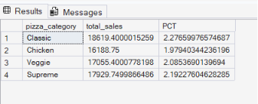

- Percentage of sales by pizza size
select pizza_size ,SUM(Total_price) AS total_sales, SUM(total_price) * 100 / (select SUM(Total_price)
from [pizza_sales (3)]) AS PCT
from [pizza_sales (3)]
GROUP BY pizza_size

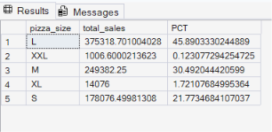

- Top 5 best sellers
select TOP 5 pizza_name , SUM(total_price) AS total_revenue from [pizza_sales (3)]
GROUP BY pizza_name
ORDER BY SUM(total_price) DESC

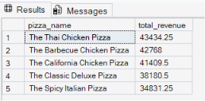

- Top 5 best quantity
select TOP 5 pizza_name , SUM(quantity) AS total_quantity from [pizza_sales (3)]
GROUP BY pizza_name
ORDER BY SUM(quantity) DESC

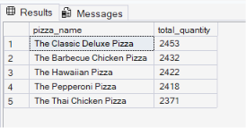

- Top 5 best pizza orders
select TOP 5 pizza_name , COUNT(DISTINCT order_id) AS total_orders from [pizza_sales (3)]
GROUP BY pizza_name
ORDER BY total_orders DESC

